1. Write a complete program that does the following:

- Declare a structure called employee with two elements:

- name: type string

- salary: type float

- Prompt user to enter number of employees

- Create a dynamic array of structure employee (array size equals number of employees)

- Prompt user to enter employee name and salary

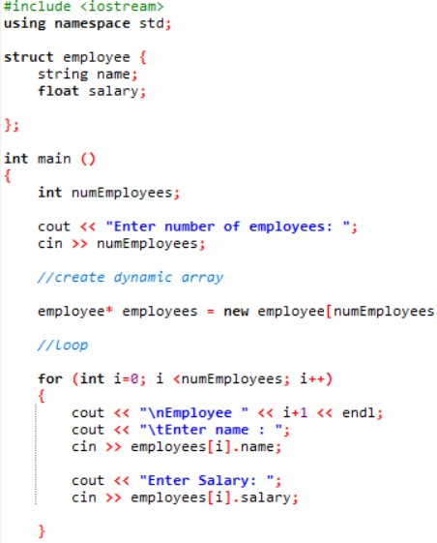

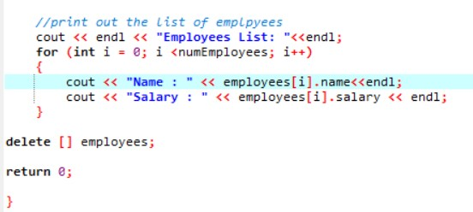

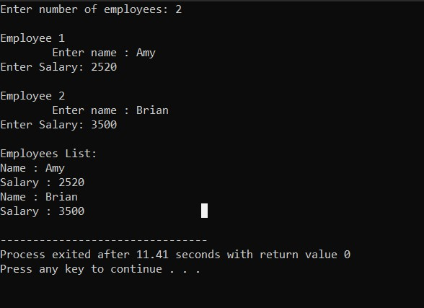

Write a program that calculates volume of two boxes, Box 1 and Box 2. Construct class Box. The class has public members : length, breadth, height.

Initialize the following values accordingly.

Box 1 : Length = 5.0 , Breadth = 6.0 , Height = 7.0

Box 2 : Length = 10.0 , Breadth = 12.0, Height = 13.0

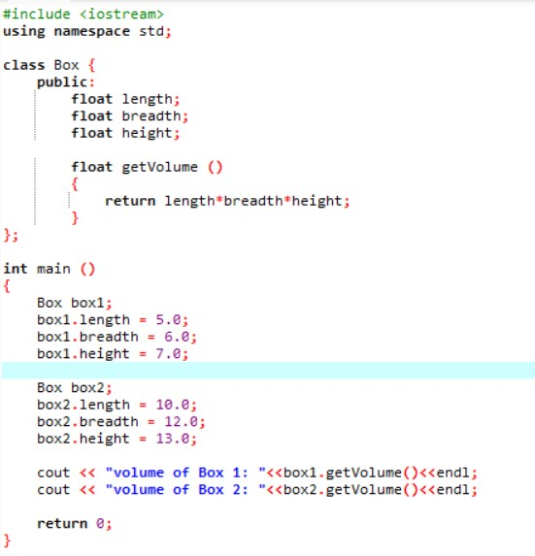

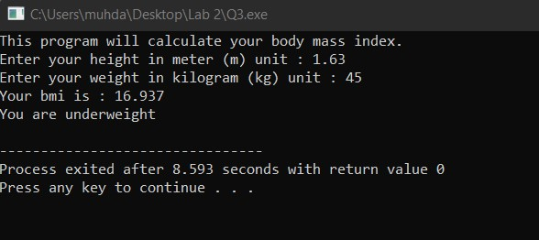

Write a program that calculates body mass index. Construct class BMI. The class has private members:

float height, float weight, float bmi and public members :

* BMI() – initialize the height and weight to 1.0.
* void set(float, float) – set the value to height and weight
* void calculate()- calculate the BMI where bmi = weight(kg)/(height(m)\*height(m))
* void display() – display the weight status.

The program will ask user to enter his/her weight and height to get the bmi. After the

programs calculate the bmi, the program will display message to user according to

their weight categories.

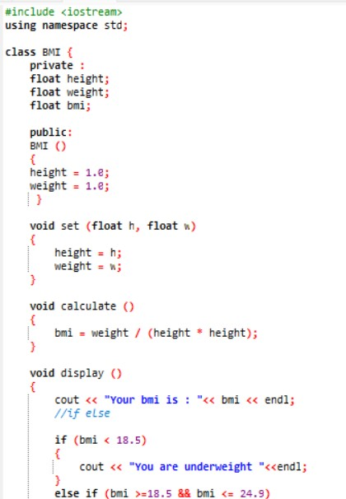

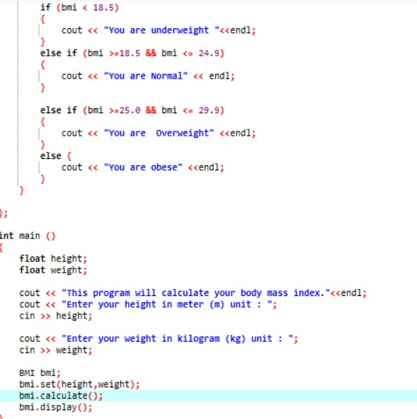

4. Write a simple program that will show the effect of passing an integer by reference

and passing an integer by value.

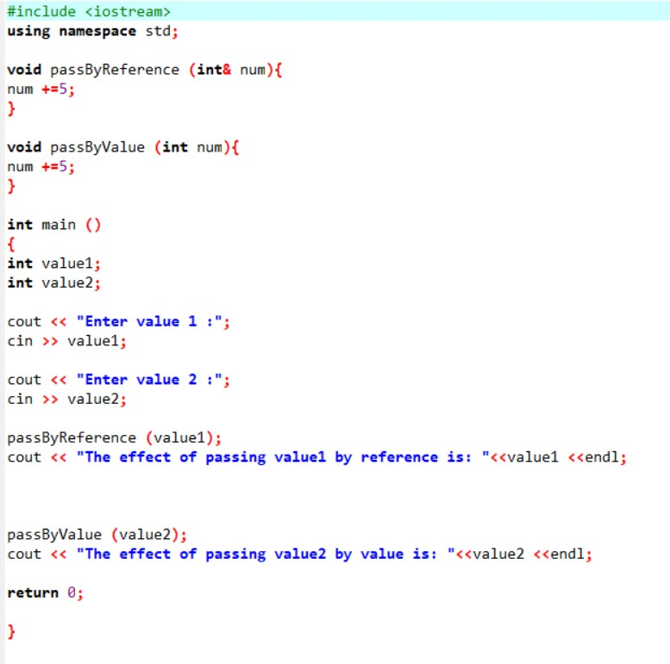

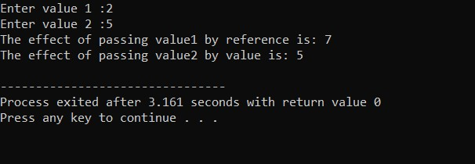

5. Write a program that asks user to insert marks and calculate sum and average of the

marks entered. Numbers of marks entered will depend on the user. Use dynamic array.

new to dynamically assigns space to store elements entered by user.

